University of Messina



Bachelor of Data Analysis

ACADEMIC YEAR - 2022/2023

SOFTWARE ENGINEERING

(Project proposal)

**E-commerce Software System**

Supervisor : Students :

Prof. Salvatore Distefano Sahil Nakrani

Yoshan Mendis

Henok Taddese

**Introduction**

The proposed e-commerce software system aims to provide a comprehensive platform for online shopping, integrating essential features such as authentication, shopping cart management, checkout and payment processing, shipping, and tracking, order management, and invoicing. In addition, the system will incorporate advanced functionalities like notification channels, map services for order tracking, chatbot-based customer support, referral programs, discount coupons, and user dashboards with personalization options and wallet management.

**Analysis and Requirements**

**CORE FEATURES:**

* **Authentication and Authorization:**

Implement a secure authentication mechanism allowing only authorized users access to the system. Use CRUD operations for managing user accounts and permissions.

* **Shopping Cart:**
  + - * 1. Enable customers to add products to their shopping cart and manage contents before checkout.
* **Checkout and Payment:**

Facilitate a seamless checkout process with integrated payment options such as PayPal, GPay, and pagopa. Integrate with external APIs for payment processing.

* **Shipping and Tracking:**

Allow customers to select shipping methods and track orders. Utilize external APIs for shipping management (e.g., UPS, BRT).

* **Orders and Invoicing:**

Enable customers to view order history and invoices. Implement order management functionalities.

**ADDITIONAL FEATURES:**

* **Notification Channel :**

Implement a notification system to update users about order status, promotions, and other relevant information.

* **Map Service for Order Tracking :**

Integrate map services to enable users to track order locations and view their current location for address verification.

* **Chatbot for Customer Support :**

Provide an automated chatbot for customer support using third-party APIs.

* **Referral Program :**

Implement a referral system to encourage users to invite new users to the platform.

* **Discount Coupons :**

Offer discount coupons to users for promotional purposes.

* **User Dashboard :**

Develop a personalized dashboard for users, including features like order history, coupons, referrals, and wallet management.

* **Wallet System :**

Implement a wallet feature for users to accumulate coins and cashbacks for transactions on the platform.

**ADMIN MANAGEMENT:**

* **Product Management**

Allow administrators to manage products through CRUD operations.

* **Analysis and Reporting**

Provide administrators with reporting and analysis features to analyse sales, traffic, and other metrics.

* **Customer Support**

Enable administrators to monitor and manage customer support interactions.

* **Promotion Management**

Allow administrators to create and manage promotional campaigns, including discount coupons and referral programs.

* **User Management**

Provide administrators with tools for managing user accounts and permissions.

* **Order Management**

Enable administrators to view and manage orders efficiently.

**Blueprint Architecture**

The system uses JWT (JSON Web Tokens) for authentication and authorization. The authentication service manages user accounts and permissions and communicates with the API gateways. The API gateways provide a unified interface for accessing the system's services, including product management, shopping cart, checkout, shipping, and tracking. The system uses two databases for managing data: one for product, order, and inventory data, and another for payment, shipping, and other details.

The following is a high-level architecture of the e-commerce software system:

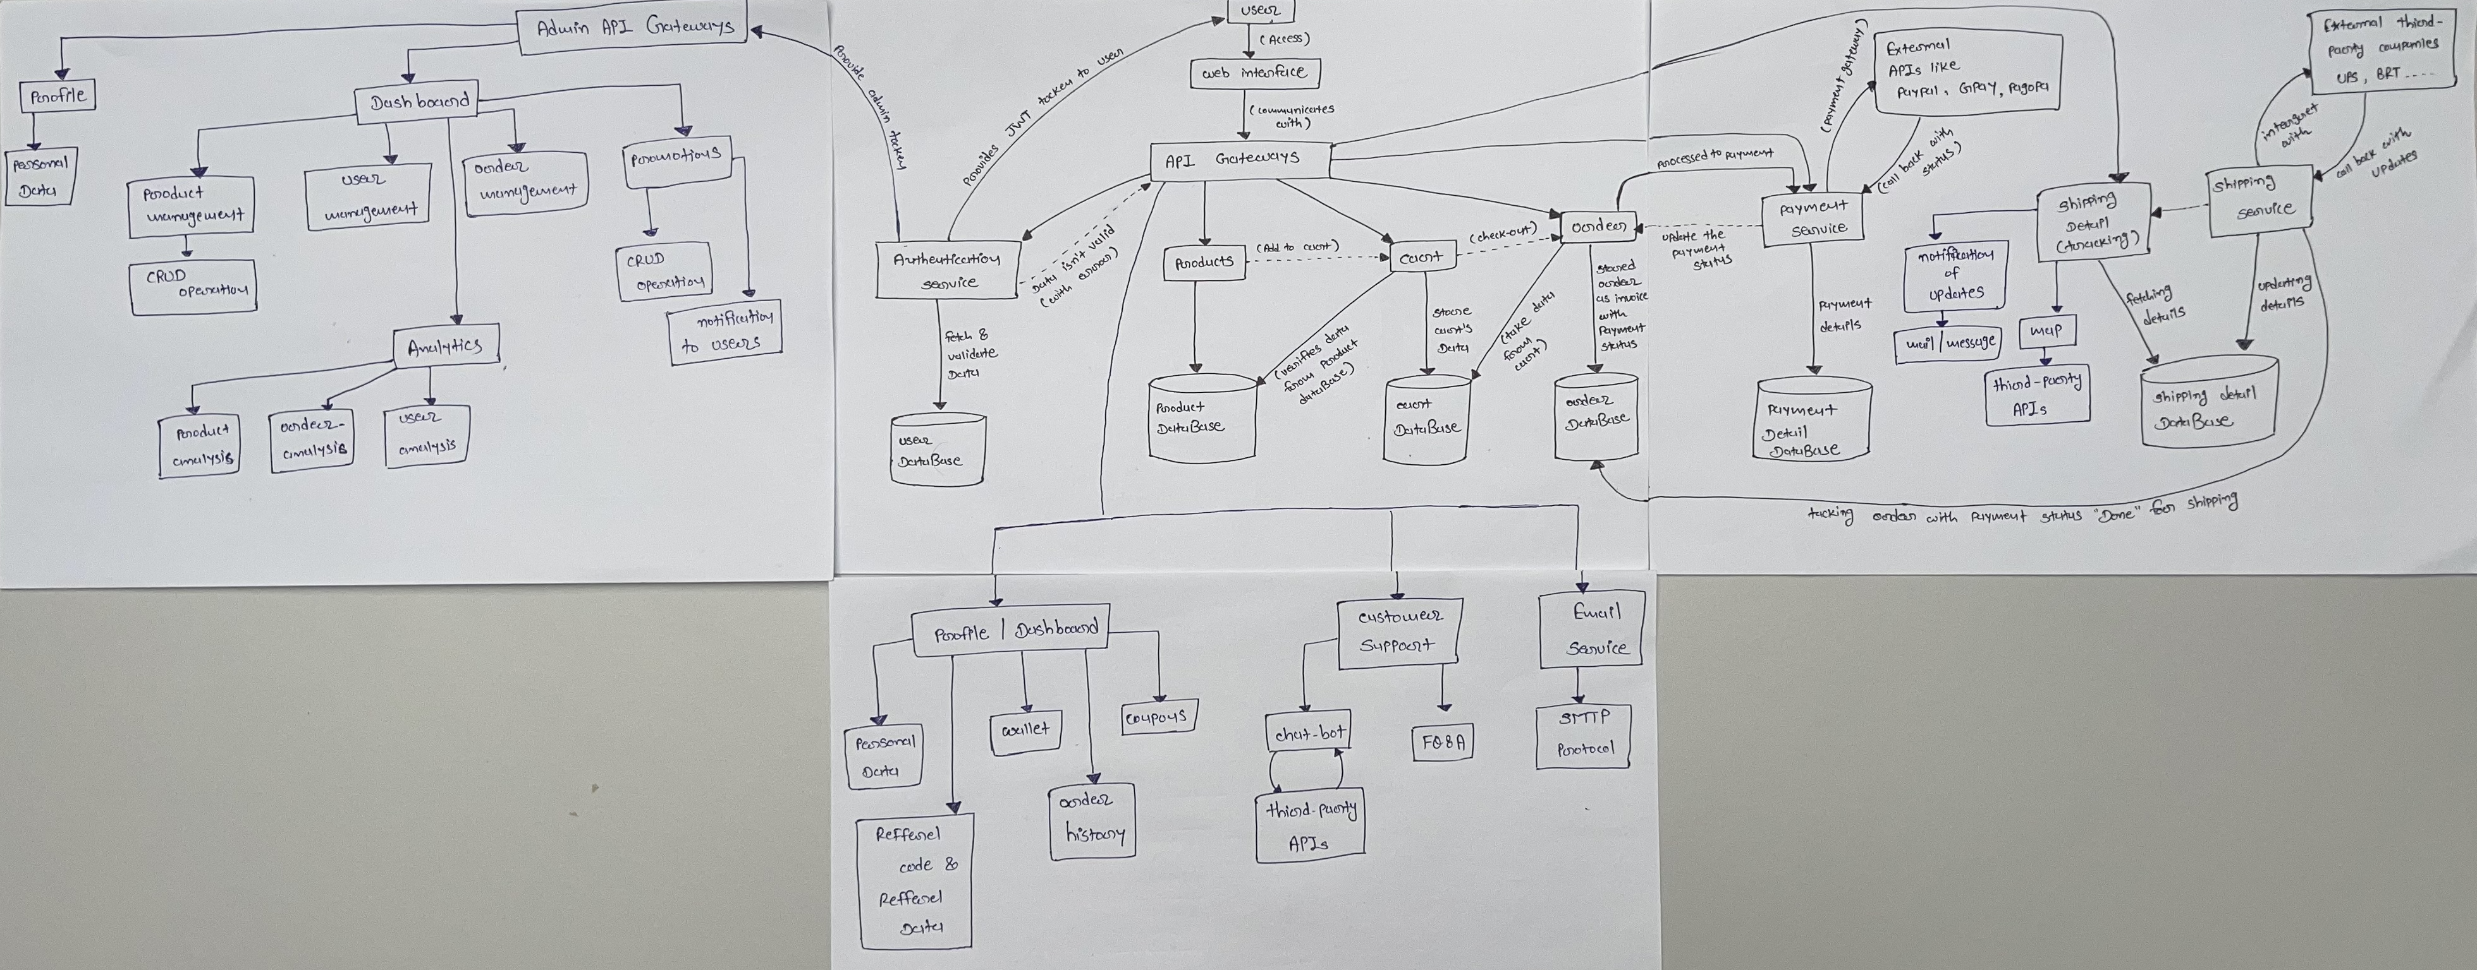

**User Journey Flowchart**

The following is a flowchart of the user journey in the e-commerce software system:

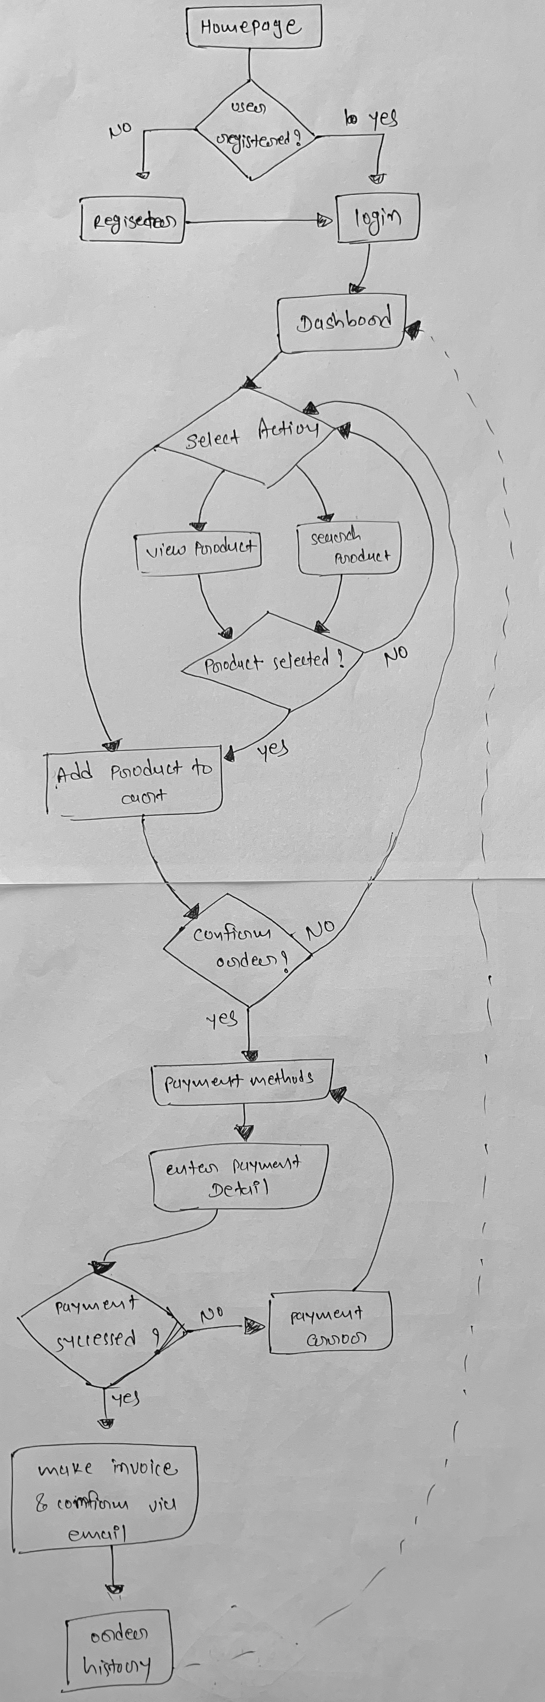

**Conclusion**

The proposed e-commerce software system aims to deliver a feature-rich platform that serves to both customers and administrators, ensuring a seamless shopping experience, efficient management, and robust analysis capabilities.